Westward Expansion Essential Knowledge Study Guide

USII.2a – Physical Features/Climate of Great Plains
• Flatlands that rise gradually from east to west.
• Land eroded by wind and water
• Low rainfall
• Frequent dust storms
Because of new technologies, people
saw the Great Plains not as a “treeless
wasteland” but as a vast area to be
settled.

Inventions and Adaptations
• Barbed wire • Railroads
• Steel plows • Windmills
• Dry farming • Wheat farming
• Sod houses • Beef cattle raising

Reasons for Increased Westward Expansion
• Opportunities for land ownership
• Technological advances, including the
Transcontinental Railroad
• Possibility of obtaining wealth, created by the
discovery of gold and silver
• Desire for adventure
•Desire for a new beginning for former slaves

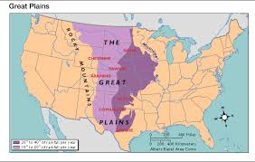
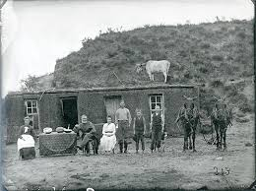

Impact on American Indians
• Opposition by American Indians to westward
expansion (Battle of Little Bighorn, Sitting Bull,
Geronimo)
• Forced relocation from traditional lands to reservations
(Chief Joseph, Nez Percé)
• Reduced population through warfare and disease
(Battle of Wounded Knee)
• Assimilation – attempt to blend Native Americans into
American culture by changing their lifestyle (teach
them to farm instead of hunt buffalo, cut hair, etc.)
• Reduced their homelands through treaties that were
broken

Influential Native Americans
• Sitting Bull and Crazy Horse – Sioux
-Defeated Custer at the Battle of the Little Bighorn
• Chief Joseph – Nez Percé
-Tried to lead his people to freedom by escaping to
Canada, but was forced to surrender 30 from border
• Geronimo – Apache
-Last Indian to formally surrender to the U.S. Army

