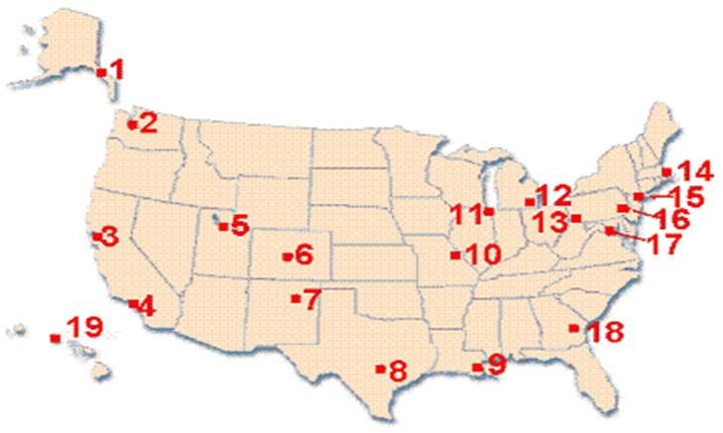
State Number Region
PITTSBURGH PA 13 Northeast____________
NEW YORK__________ __________ _______________________
SANTA FE__________ __________ _______________________
DENVER__________ __________ _______________________
SAN FRANCISCO__________ __________ _______________________
ST. LOUIS__________ __________ _______________________
BOSTON_______________ __________ _______________________
SALT LAKE CITY__________ __________ _______________________
SAN ANTONIO__________ __________ _______________________
ATLANTA__________ __________ _______________________
NEW ORLEANS__________ __________ _______________________
WASHINGTON, D.C. __________ __________ _______________________
JUNEAU__________ __________ _______________________
LOS ANGELES__________ __________ _______________________
SEATTLE__________ __________ _______________________
PHILADELPHIA__________ __________ _______________________
DETROIT__________ __________ _______________________
HONOLULU__________ __________ _______________________
CHICAGO___________ __________ _______________________

