Spanish American War (1898) Essential Knowledge Study Guide
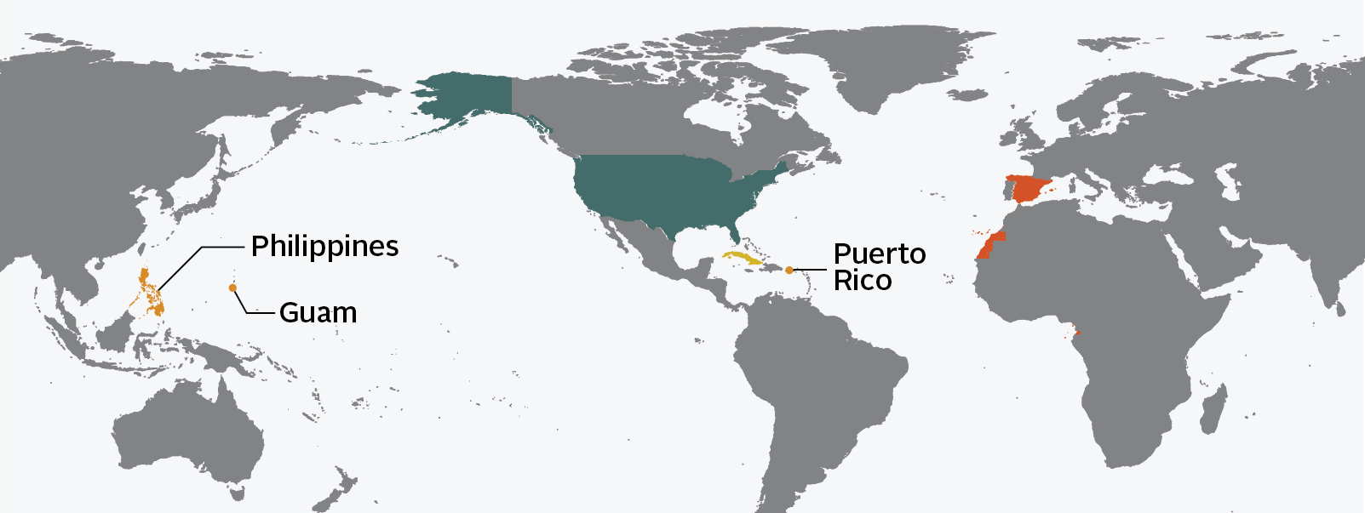
U.S.A.
Cuba
Spain

Reasons for the Spanish American War Results of the Spanish American War
• Protection of American business interests in Cuba • The United States emerged as a world power.
- Sugar Cane •Cuba gained independence from Spain.
• American support of Cuban rebels to gain •The United States gained possession of the Philippines,
independence from Spain Guam, and Puerto Rico.
• Rising tensions between Spain and the
United States as a result of the sinking of
the USS Maine in Havana Harbor
• Exaggerated news reports of events
- yellow journalism

The Roosevelt Corollary to the Monroe Doctrine
• asserted the United States’ right to interfere in the
economic matters of other nations in the Americas
• claimed the United States’ right to exercise international
police power
• advocated Big Stick Diplomacy
- building the Panama Canal
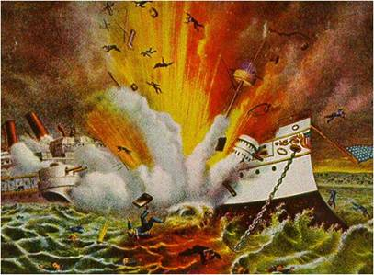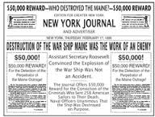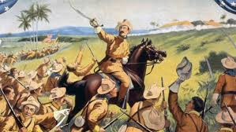
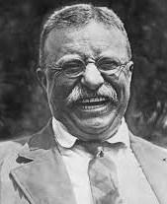 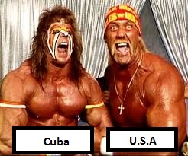 VS.

