Southwest Region

Arizona - AZ
New Mexico - NM
Oklahoma - OK
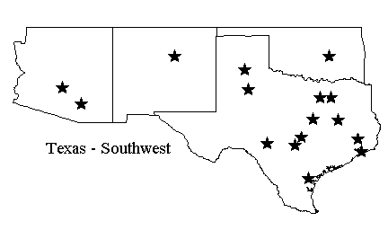
Texas – TX

