Post WWII Summary

World War II, Rebuilding Europe and Asia (1945-1950)
Much of Europe was in ruins after WWII. The Soviet Union controlled most of Eastern and Central Europe. The United States felt they should rebuild Europe to prevent political and economic problems from happening again. The U.S. also wanted to weaken the Soviet Union’s influence in Europe.

European economies were in trouble after WWII. Communism (a belief that there should be no rich or poor people) began to be attractive to many Europeans. What most Europeans did not understand was that individual freedoms are often limited in Communist countries. Communism is different than Capitalism. Capitalist believe you should be able to make money, even if some people don’t. Capitalism is centered on citizens having many individual freedoms. The U.S. created the Marshall Plan to send massive amounts of financial and material (products) aid to Western European countries like France, Italy, and West Germany. The U.S hoped the Marshall Plan would (1)help Europe rebuild and (2)stop the spread of communism in Western Europe.

Germany was split into two sides, East Germany and West Germany. The East was controlled by the Soviet Union. The West was controlled by the U.S., Great Britain and France but eventually was able to govern itself with its own democratically elected government. Japan was controlled by the United States for few years before it began to govern itself. Japan adopted a democratic form of government and became a strong ally of the United States.

The United Nations was created to provide a place for countries of the world to talk about their problems and resolve them peacefully. The United Nations still exists today. Its headquarters is in New York City.
The U.S after WWII (1945-1960)
The American economy boomed after WWII. Because of rationing people had not been able to buy many products during the war. They saved their money instead. After WWII Americans used their savings and credit to buy products. With so many men coming back from the war the Government was worried there would be high unemployment. The Government created the G.I. Bill, which paid for veterans to go to college or get job training. Also during this time, President Truman desegregated the armed forces. Labor unions became stronger, so the men entering the workforce gained new benefits and higher wages (pay).

Women were encouraged to give up their wartime jobs to the returning veterans. They were expected to stay home and raise a family. In what was known as the “Baby Boom”, over 65 million children were born during this time. FDR’s wife, Eleanor Roosevelt, became a role model for women who wanted careers when she was chosen to be the U.S. Representative to the United Nations. Eleanor Roosevelt used this position to help write the U.N. Declaration of Human Rights.

The U.S. was transformed by the new system of highways created by President Eisenhower’s Highway Act of 1956. The Highways were also created to make it easier to transport troops and missiles around the country in time of war.

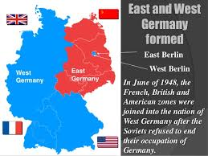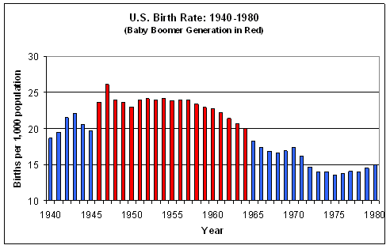
Post WWII (1945-1960) Summary Questions Name:___________________
1. Use the chart to contrast the two economic systems.
Communism | Capitalism

2.
What was the Marshall Plan?
What were the two goals of the Marshall Plan?

3. List the countries that controlled each section of Germany following WWII.

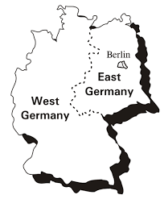
__________________________

__________________________

__________________________
__________________________

4. Following WWII Japan became a strong ____________________ of the U.S.

5. The ________________________ ________________________ was created to help countries solve problems peacefully.

6. What was the G.I. Bill?

7. President Truman _____________________________________ the armed forces.

8. How did labor unions benefit Americans following WWII?

8. The ____________________ ________________________ caused the population to increase rapidly.

