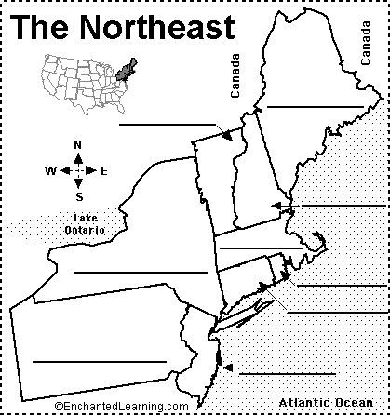

Northeast Region
Connecticut – CT
Delaware - DE
Maine - ME
Maryland - MD
Massachusetts - MA
New Hampshire- NH
New Jersey - NJ
New York - NY
Pennsylvania - PA
Rhode Island - RI
Vermont - VT

