Name:_______________________
The Great Depression and the New Deal Outline
Summary:
-The optimism of the 1920’s concealed ________________ in the American economic system and attitudes about the role of government in controlling the _____________________.
-The Great Depression had a widespread and severe impact on American life
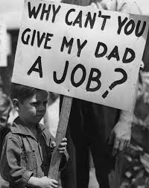
-____________________ _________________________ New Deal used government programs to help the nation recover from the Depression.

A. The Great Depression lasted from _________ to around ___________.
1. A depression is a long-lasting downturn in the economy (businesses and jobs).

B. Causes of the Great Depression
1. The ________________ _________________ crash of ____________- many people overspeculated (made
risky investments, often using borrowed money) on stocks, trying to make a fast profit. Everyone tried to sell
their stocks all at once in October ________. This caused stock prices to __________ rapidly.
*People that borrowed money to buy stocks could not repay their __________ when stock prices dropped.
2. The ________________ ______________ failed – the _________________ ___________________ failed to
prevent the collapse of the banking system.
*The __________________ _________________ is the government-run central bank that is supposed to
keep the banking system working properly.
3. ________ _______________ discouraged _______________________ ____________.
* _________________ are taxes on imported goods. Countries stopped buying our taxed goods.
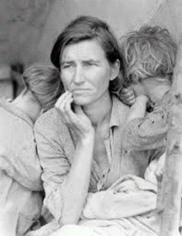
C. The Great Depression had a severe impact on Americans.
1. Many _______________________ and _____________ failed.
2. Many workers had no job. ____________________ (25%) of workers were unemployed.
3. ________________ incomes fell to low levels.
4. Many people were ___________________ and _________________.

D. Between 1930 and 1936 the Great Plains was struck with a severe drought that caused the “__________ _________.”
1. Lack of rain, combined with years of neglecting the land through poor farming techniques
turned the soil to dust.
2. The dust was picked up by winds causing dust storms called “______________ _______________________.”

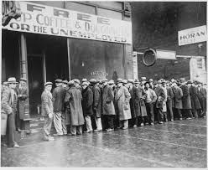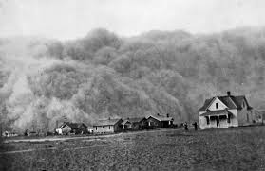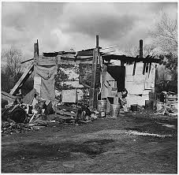

Great Depression and the New Deal Outline page 2

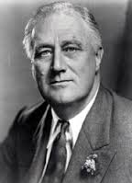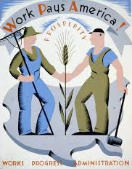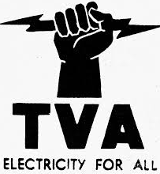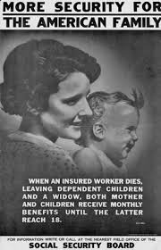

E. Franklin Roosevelt was elected President in 1932 by promising a “___________ _____________.”
1. FDR defeated President Hoover in 1932. Hoover believed individuals should help the needy, not the
______________________. FDR promised to get the federal government directly involved in helping the nation.
2. FDR gave fireside chats over the _________________ to address the nation.

F. Major features of President Franklin Roosevelt’s New Deal.
1. Federal work programs- created jobs in public works projects, such as _____________ and ________________.
2. ________ assistance programs- paid farmers to leave some land unplanted in order to reduce overproduction.
3. Environmental improvement programs- built or improved ___________, planted trees to control erosion.
4. Increased rights for ___________- a minimum wage law was passed and laws to help labor unions.
5. Social Security- new programs were created that gave government payments to _____________ workers, the
widow/children of workers who die, and ____________________ people unable to work.

G. The impact of FDR’s New Deal programs
1. They helped many people by creating _____________ and restoring ______________.
2. They led to a bigger role for the federal government in American ________________.
3. They led to higher _____________ to pay for the new government programs.
4. They did not, however actually end the Depression. It took the start of World War II to do that.

