D-Day – The Invasion of Normandy
On June 6th, 1944 the invasion of Normandy (codenamed Operation Overlord) began as 156,000 American, British, and Canadian forces landed on five beaches along a 50 mile stretch of heavily fortified coast in France’s Normandy region. The Allies knew that to defeat the Germans they were going to have to land in Europe and invade Germany. The Normandy landings have been called the beginning of the end of war in Europe.

The Allies were faced with several challenges. They had to transport thousands of men, supplies, and weapons across the English Channel, and win the landing beaches that were heavily fortified. They had to quickly build their forces and repel any counterattack the German may mount. Then, they had to slowly fight their way hundreds of miles inland to Germany. General Dwight Eisenhower was appointed the commander of Operation Overlord. Months of detailed planning went into the attack. The Allies decided to drop several thousand paratroopers behind the beaches during the night. Their mission was to attack the fortified positions overlooking the beaches and to control the roads leading from the beaches. As morning approached the Allied navy would start blasting the beaches with artillery to weaken the German defenses. After the bombardment, the Allies would attack at first light during low tide so that they could see and avoid the German defenses. Although extremely well planned, the invasion did not go as expected. The success of the mission depended on the bravery and perseverance of the Allied men attacking the beaches.
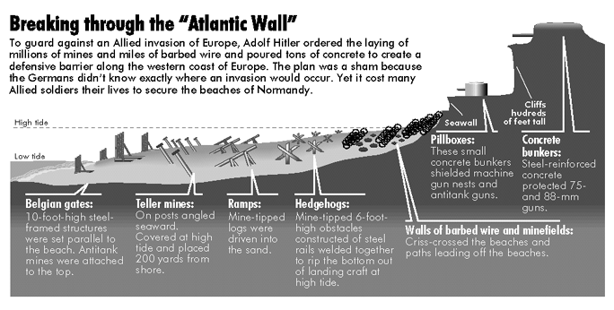
Hitler appointed Erwin Rommel as the head of defending the Allied invasion. While the Germans knew the invasion was going to happen, they did not know when or where the invasion would take place. The Allies even tried to fool the Germans into thinking the attack would occur at a different location (Operation Fortitude) using fake tanks and trucks for the Germans to see during aircraft flyovers. Since they did not know where the attack would occur, German created the Atlantic Wall, a 2,400-mile fortification of bunkers, landmines and beach and water obstacles. Although the Germans created heavy fortifications, they had reduced numbers of soldiers to defend the beaches because of years of heavy casualties fighting the Soviet Union in Eastern Europe. Despite the disadvantages, Hitler understood that repelling the coming invasion back into the sea would be the only chance for Germany to win World War II. He knew the invasion of France was the most important event of the war to date, and the final overcome would play a large role in determining the victors of World War II.
